**Name: Balraj**

**ID: 3157523**

**Title: Seed Management System**

**Task 1 - Find the problem and Discussion**

**Call Discussion with Client: Babal**

Call Record Major Points Discussed are written below:

Babal Has his seed Business he said write all record manually or in excel file which become very hassle to maintain that thing now he is looking for a website in which he can upload al the record instantly and can see it anytime he want and by this way all time will saved. Further more we discussed about the overall design of the website, Time and Cost.

**Requirement of The Software**

Scope of Work

*Features: I am going to create software of Seed management System. Which will be fully automated and babal can maintain and store the data for future. He can see all the customers and selling and payments through this application online. This application would be fully secure. Data will be saved in the future efficiently. And no unauthorized person can make changes in it. So Application would be very effective and efficiency.*

*Practical Requirements: Demanded Features by end client:-*

*1. He needs customer module save refresh and erase and rundown of clients to see.*

*2. Then he needs crop module in the product.*

*3. He needs crop assortment module in the product.*

*4. He needs the record of harvest rate.*

*5. He needs login and logout office in the product.*

*Non-practical prerequisites:*

*1. System ought to be versatile.*

*2. Performance of framework ought to be great.*

*3. System ought to be solid.*

*4. System ought to be adaptable.*

*5. System ought to be secure.*

Time: It will take minimum 20 days to complete.

Total Hours taken to complete the Project is **24 Hours**

The 4 essential steps of the Risk Management Process are:

1. Identify the risk.
2. Assess the risk.
3. Treat the risk.
4. Monitor and Report on the risk.

Project management:-

Managing the Project with Skills, Knowledge and Experience to get targeted goal with time requirements. Its result is limited to limited time frame and budget.

Total Cost: $700

Web Hosting and Domain Cost approx. 100 Dollars

Working Per Hour at 25Dollars

Total = Total Time * 25 Dollars

**24*25 = 600 Dollars**

**Task 3 - Design mockups**

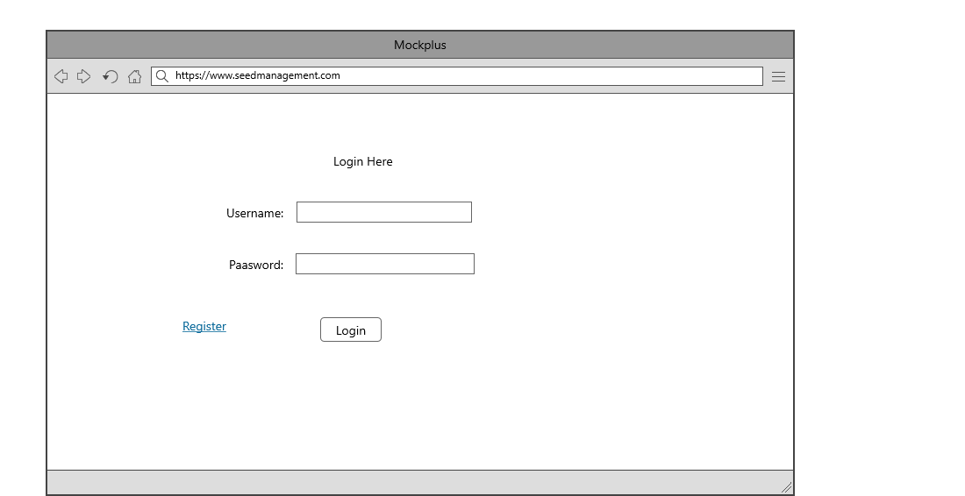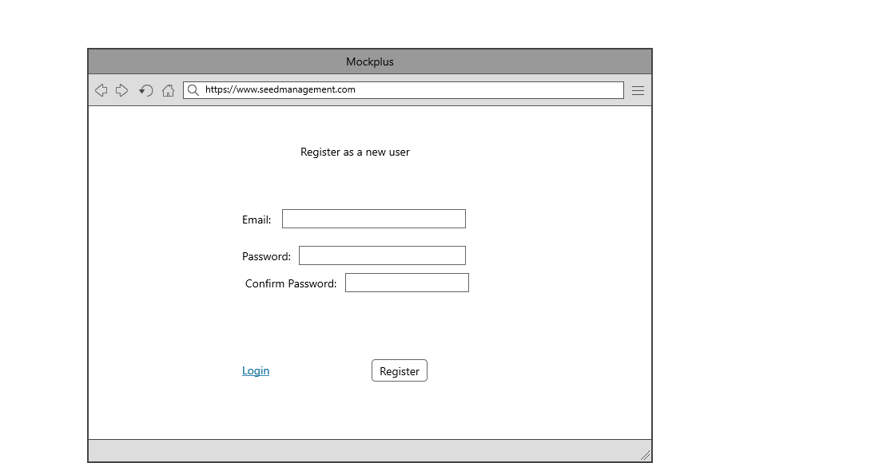

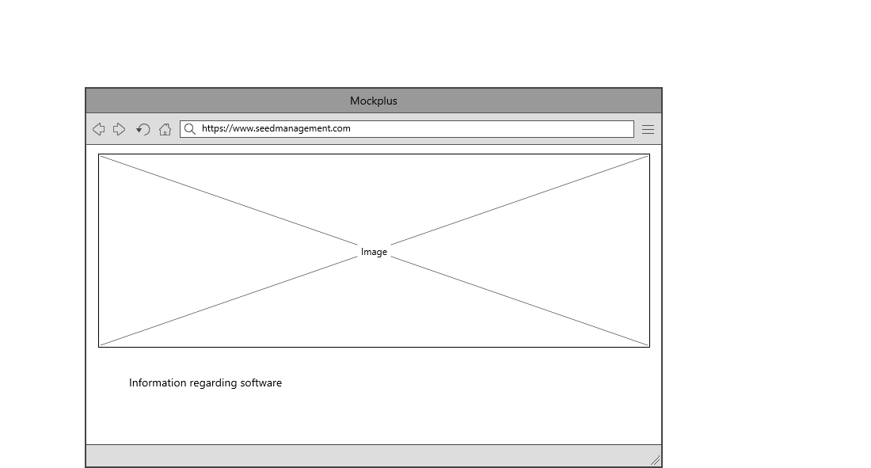

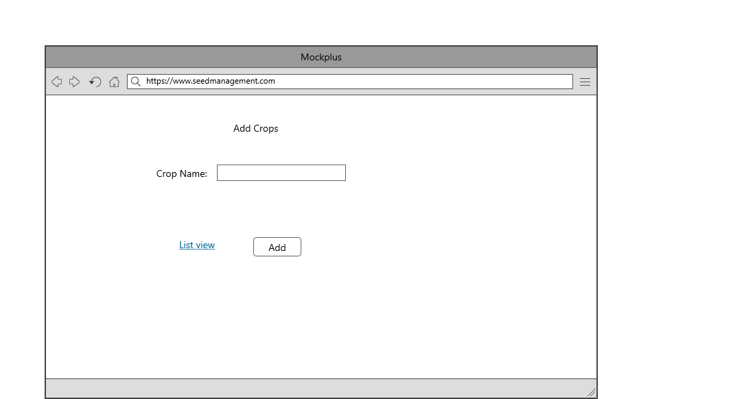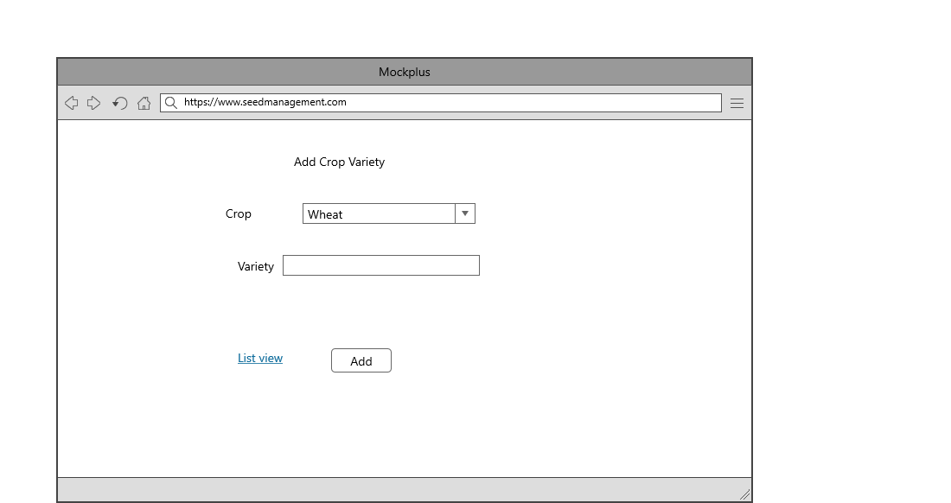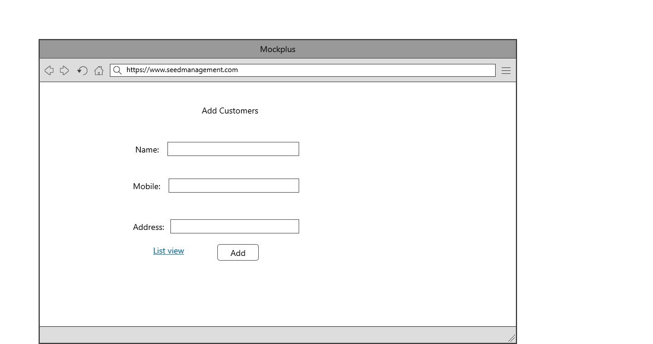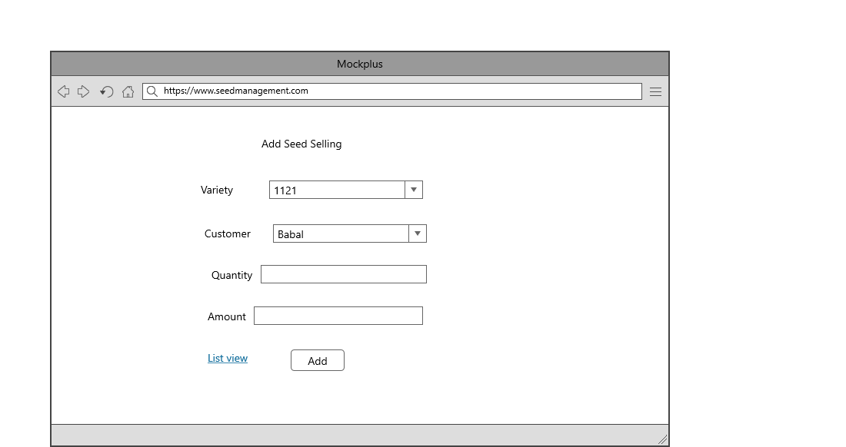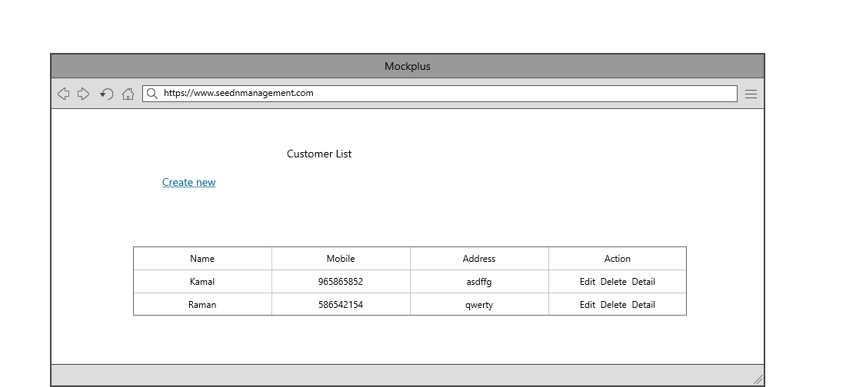

## Task 5- usability testing

|  |  |  |  |  |  |
| --- | --- | --- | --- | --- | --- |
| **User #** | **Login form** | **Customer form** | **Selling Module** | **Pass / Fail / Not executed / Suspended** | **Reviews** |
| Babal | Nice | Role based is good | As Expected perfect | Pass | all modules are as expected |
| Kunal | looking good | completed as expected | Ok | Pass | Customer form should be more attractive |
| Ranjit | might be more attractive | good | should some changes and expand more | Pass | All modules are ok |
| Karan | Nice | Good | Perfect | Pass | Perfect |

**Task 6 - Meet with your client**

Client Meeting:

|  |
| --- |
| Meeting Details |
| * Date and time: 25-Oct-2021 * Location: Newzealand |
| Attendees: Balraj and Babal |
| Agenda: Discussion of Software of Seed management system |
| Discussion (Important Points): He wants neat and clean software which will work effectively |
| My To Dos (Actions): Firstly I have to make the mockups of the application. Then Starting the application after the next meeting. |
| Questions requiring Follow- Up: Discussion of the mock ups |
| Comments: Jatin is good person and he described regarding software very wisely. |
| Next meeting  Date and Time: 1- Nov-2021 1:00 Pm  Location: Newzealand  Agenda: Showing the mock ups to the client and discussion about further development. |

**Appendix 3**

**Client Review Form**

My developer’sname: Balraj

This form is intended to let you review the communication skills of your developer for this assignment. Your review will partly count towards their final mark. Do not take into account technical skills.

# Grading scale

You must grade your developer for each item listed in the tables below. 1 being the lowest, 5 the highest.

|  |  |  |  |  |
| --- | --- | --- | --- | --- |
| **1** | **2** | **3** | **4** | **5** |
| Strongly disagree | Disagree | Ok | Agree | Strongly agree |

# Review your developer

|  |  |  |
| --- | --- | --- |
| **Item** | **Grade** | **Comment** |
| Communicated clearly and effectively | 2 |  |
| Kept you informed of the progress | 5 |  |
| Met timelines | 3 |  |
| Responded promptly to problems | 4 |  |
| Met overall project objectives | 2 |  |
| Was open to new ideas and suggestions | 4 |  |
| Was easy to work with | 5 |  |

Comments

Provide any extra comments on your developer’s communication skills and professionalism.

Balraj is good person and has professenalism.

## Signed by Client

|  |  |
| --- | --- |
| **Signature: Babal** | **Date: 14-nov-2021** |
| **Name:Babal** | **Title:Seed Management System** |
| **Contact details (email/Tel):** | |

**Task 8 - Software development life cycle stages**

**Planning :-** The planning phase of the SDLC is also when the project plan is developed that identifies, prioritizes, and assigns the tasks and resources required to build the structure for a project. With that said, this step culminates in a detailed project plan.

**Requirement :-** The most important phase of the SDLC is the requirement gathering and analysis phase because this is when the project team begins to understand what the customer wants from the project. After the project team receives all of the customer requirements or specifications, the team begins to analyze each requirement.

**Software Design and prototyping:-**

The Prototyping Model is one of the most popularly used Software Development Life Cycle Models (SDLC models).This model is used when the customers do not know the exact project requirements beforehand. In this model, a prototype of the end product is first developed, tested and refined as per customer feedback repeatedly till a final acceptable prototype is achieved which forms the basis for developing the final product.

Screenshots

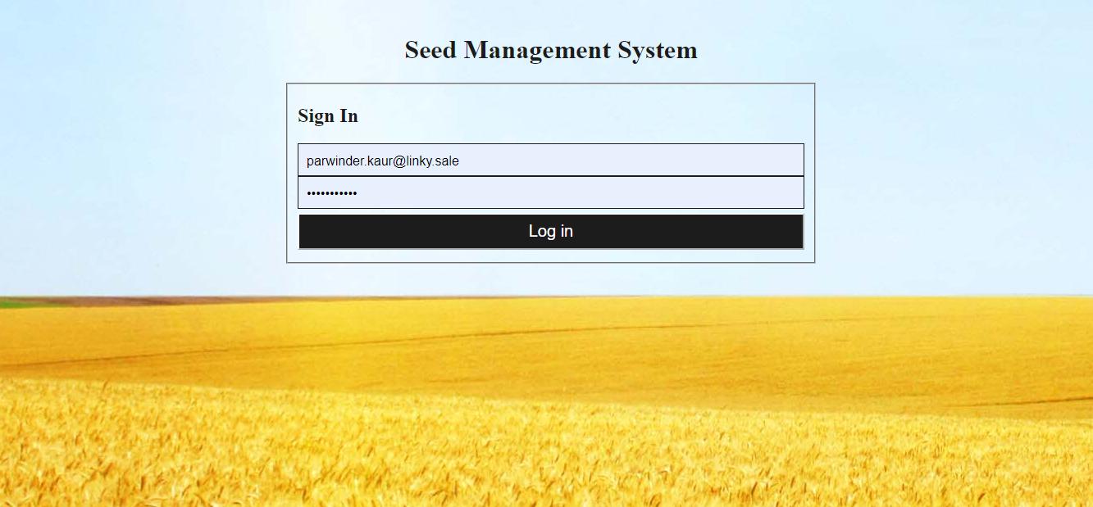.

This is login screen for Seed management system. This can be login by different roles in the system.

2. This screen is the landing page while login into the system.



1. This screenshot is to maintain details of crops.

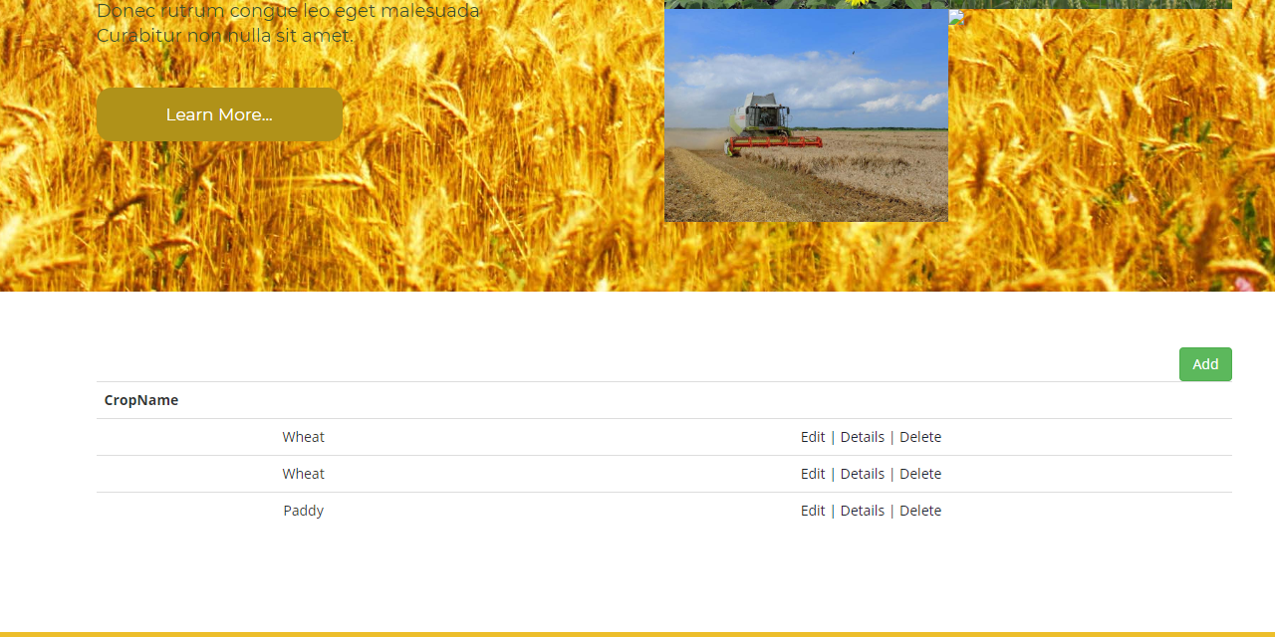

1. Crop Screen



1. Crop Variety Screen

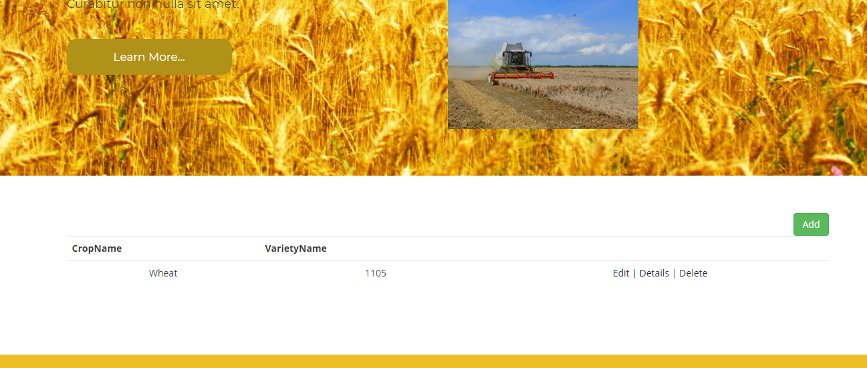

1. Create Crop Variety

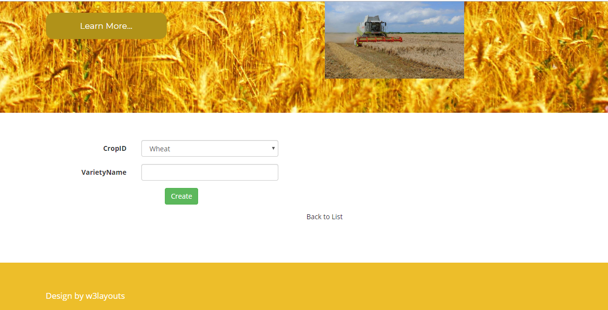

1. Crop Rate List Screen

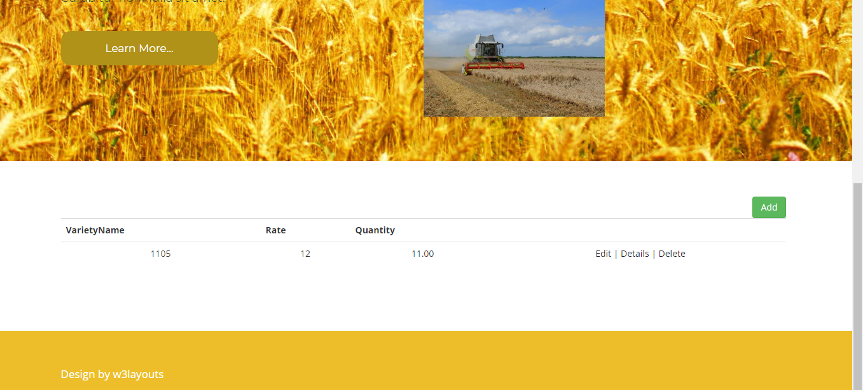

8. Edit Crop Rate

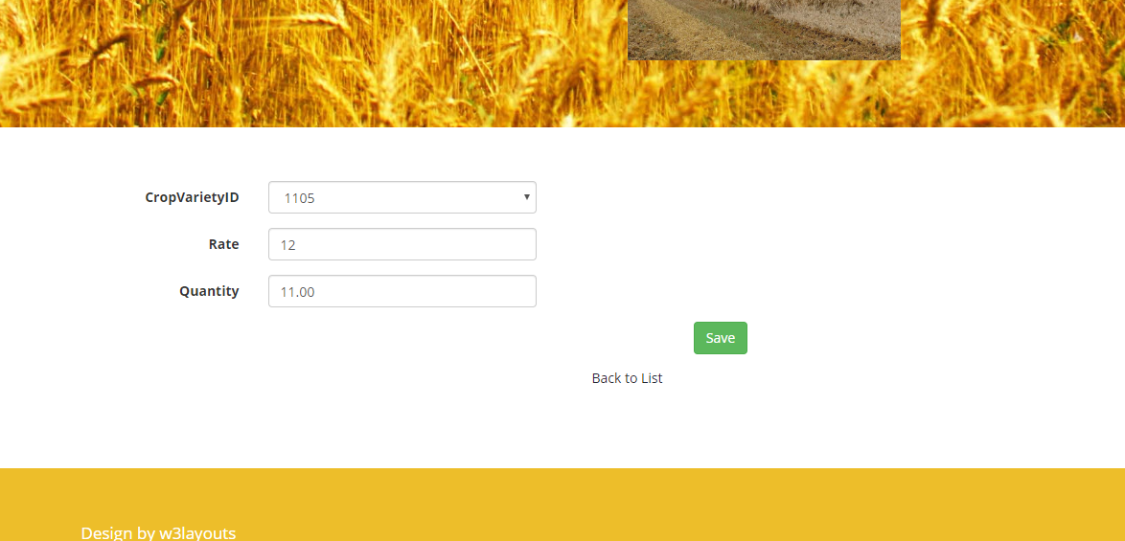

9. Store List

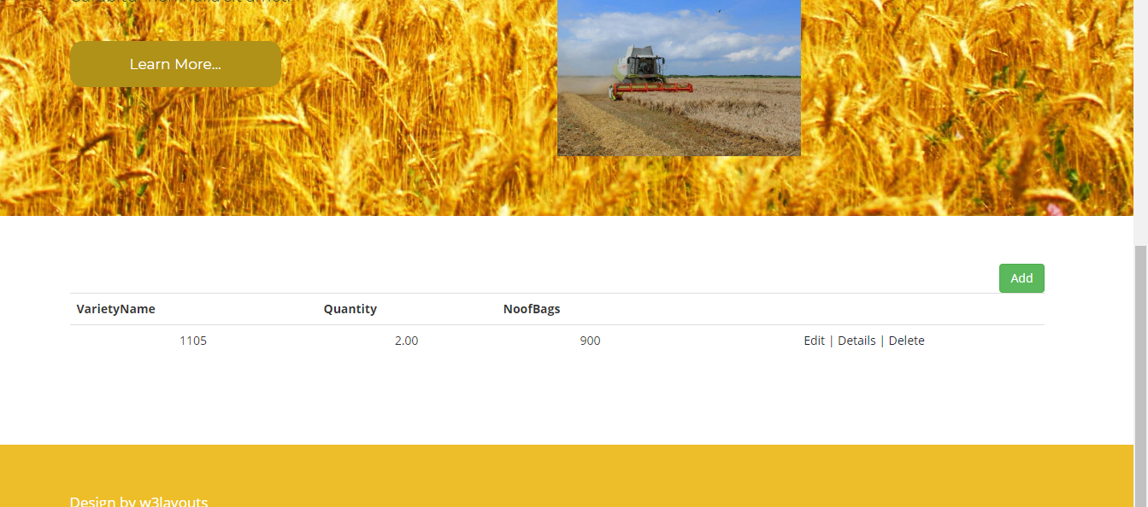

10. Create Store List

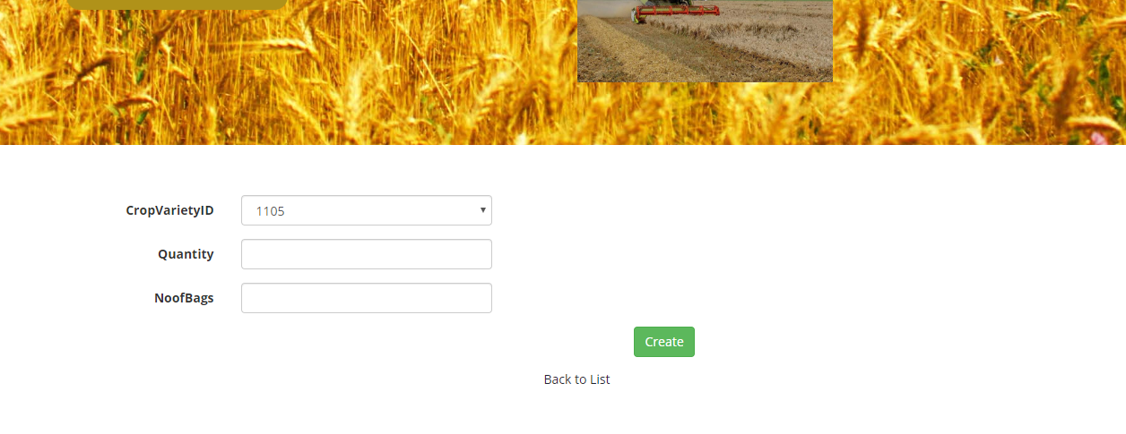

11. Customer List

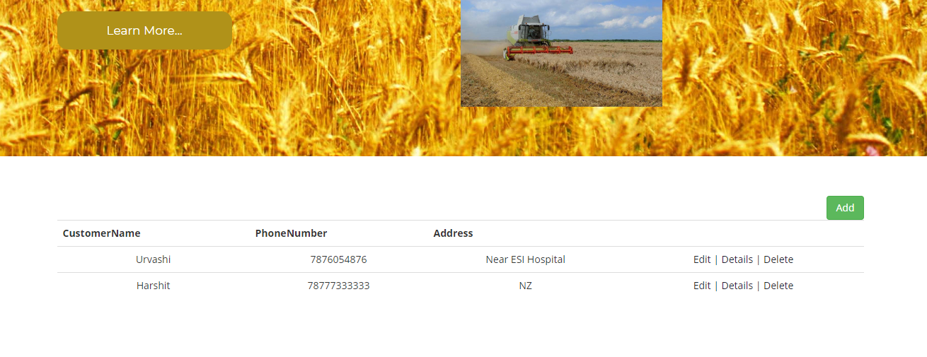

12. Edit Customer

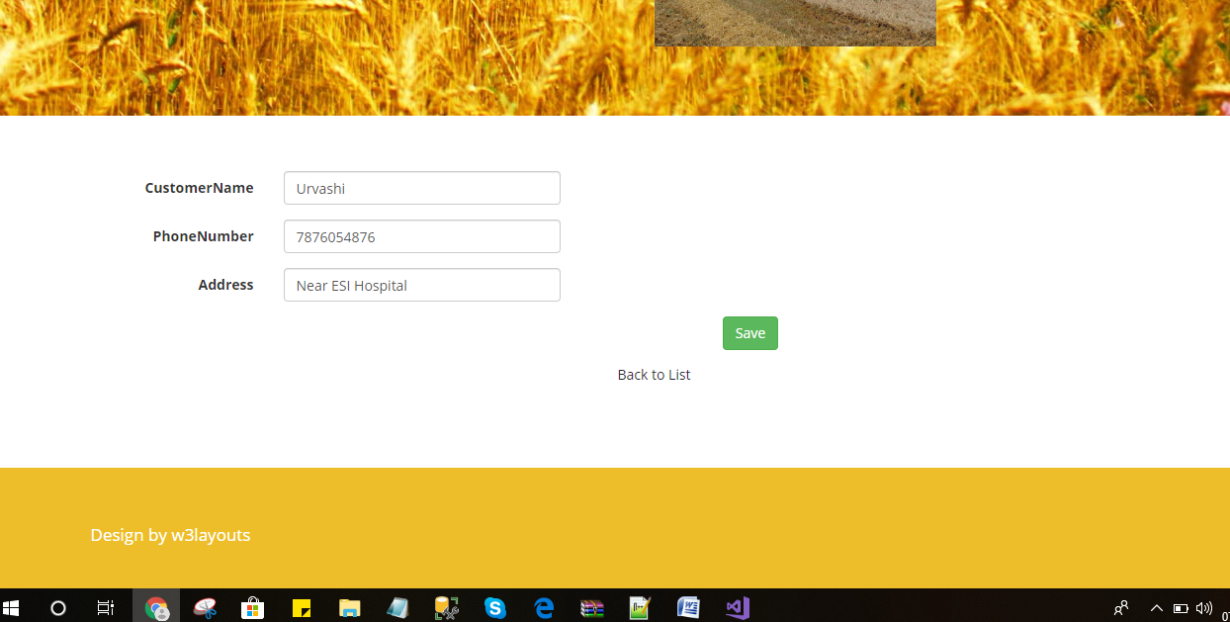

13. Seed Selling List

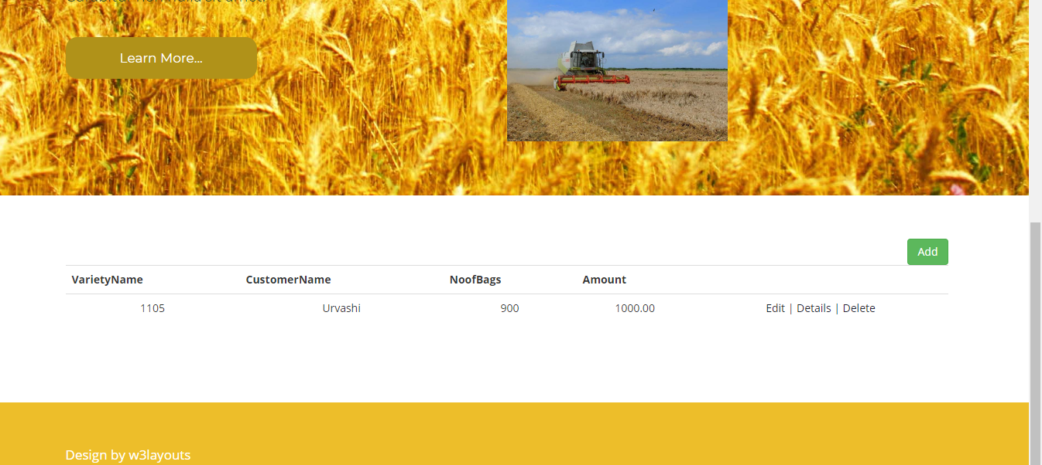

14. Create Seed Selling Record Screen

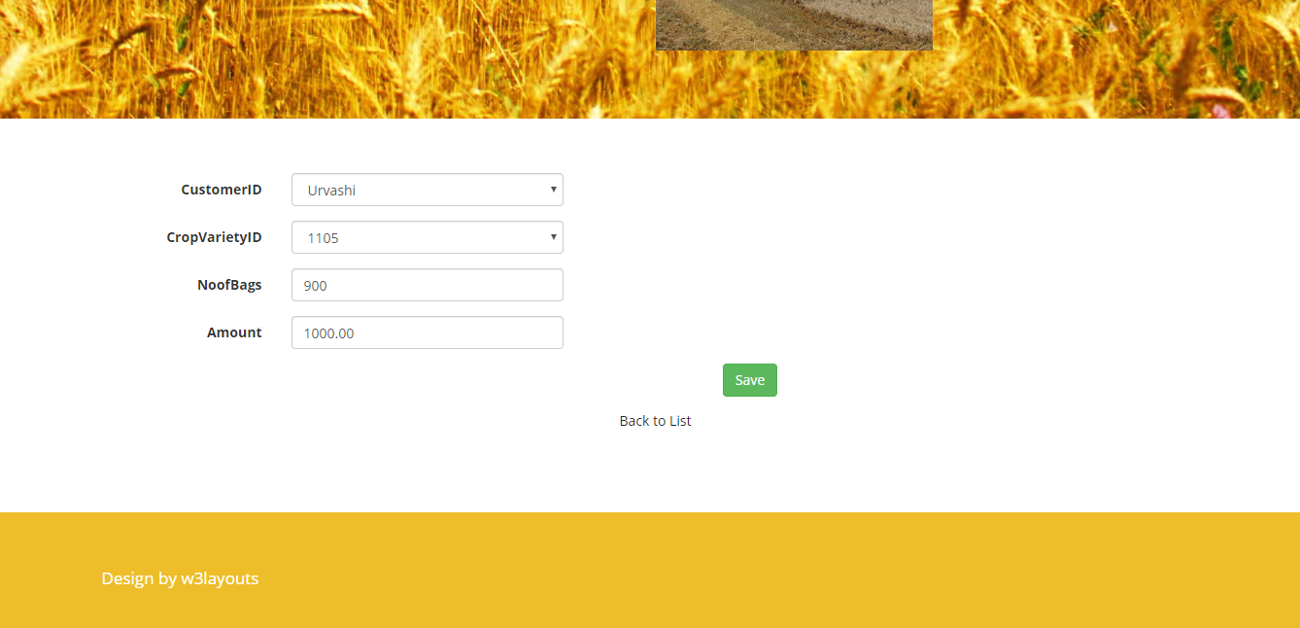

15. Bank Payment List

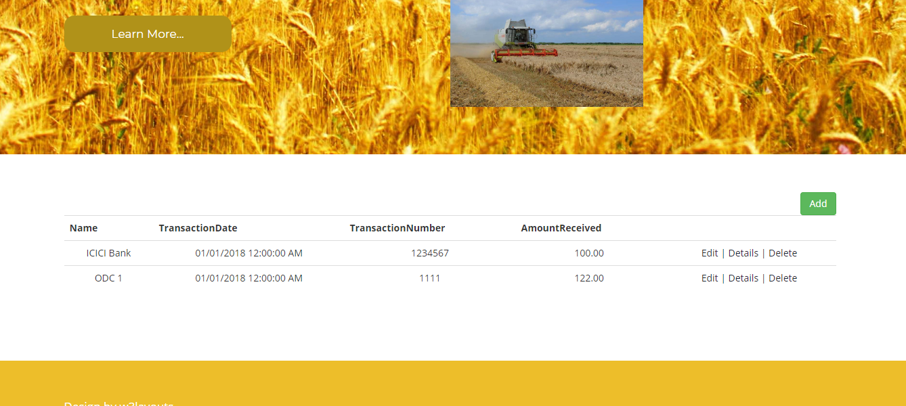

18. Bank Payment Create Screen

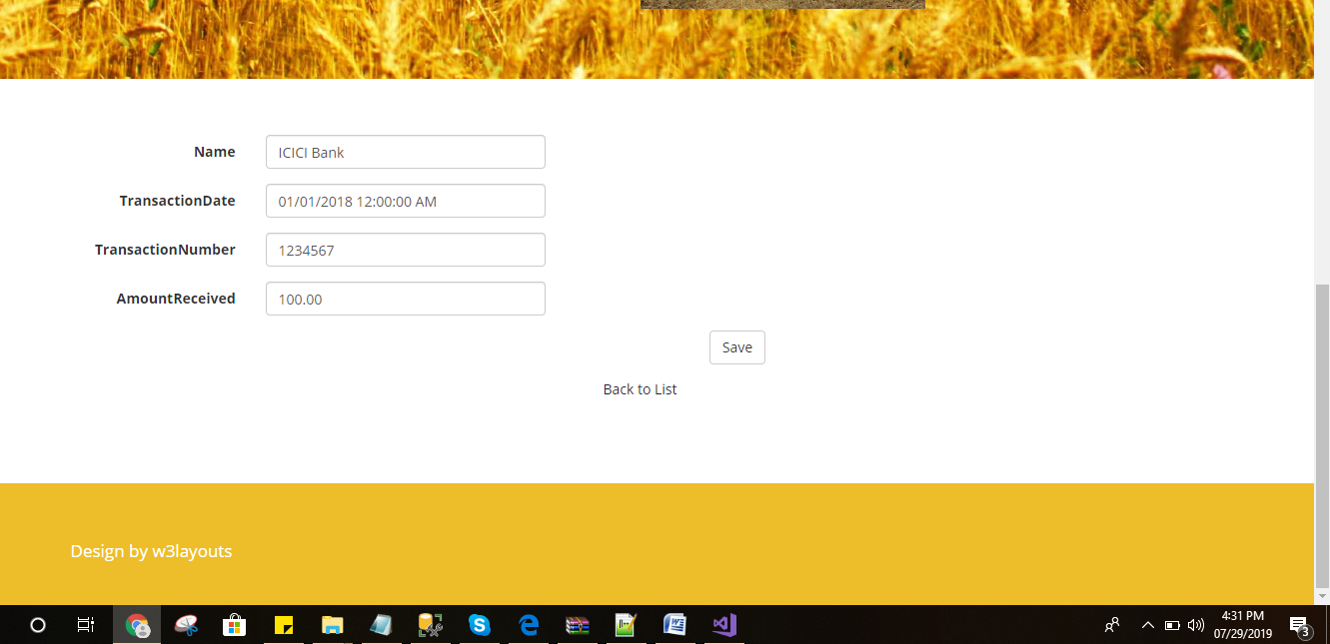

Colour: White background and Black Text

**Software Development:-**This is the actual writing of the program. A small project might be written by a single developer, while a large project might be broken up and worked by several teams. Use an Access Control or Source Code Management application in this phase. These systems help developers track changes to the code. They also help ensure compatibility between different team projects and to make sure target goals are being met.

**Testing:** The testing phase of the software development lifecycle (SDLC) is where you focus on investigation and discovery. During the testing phase, developers find out whether their code and programming work according to customer requirements.

**Task 9- Project management**

Project management is the application of processes, methods, skills, knowledge and experience to achieve specific project objectives according to the project acceptance criteria within agreed parameters. Project management has final deliverables that are constrained to a finite timescale and budget.

Principles I have followed for creating my project:-

1. I have Created clear and concise project goals.
2. I have Managed risks.
3. I have Established a performance baseline.
4. I have Established and maintained healthy communication.
5. Clearly define team responsibilities.

Project management is the science and art of organizing all the components of a project. For example, the launching of a new service, a marketing campaign, or the development of a new product are projects. In fact, even a wedding is a project that requires management.